Geometric and Arithmetic sequence Convergence Determiner

**Terminal Display:** Enter variables as: a,b. Write fractions as a float.

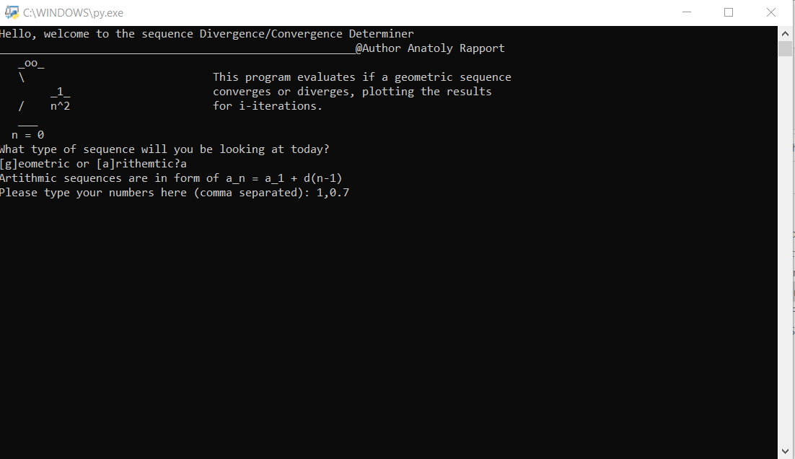

**Program Output:** displays series, legend, and limit-range,